# Ford Mustang GT Fastback

## Source

The car I will be modeling is the Fort Mustang GT Fastback (2017). I have found source material in both blueprint and real-life images.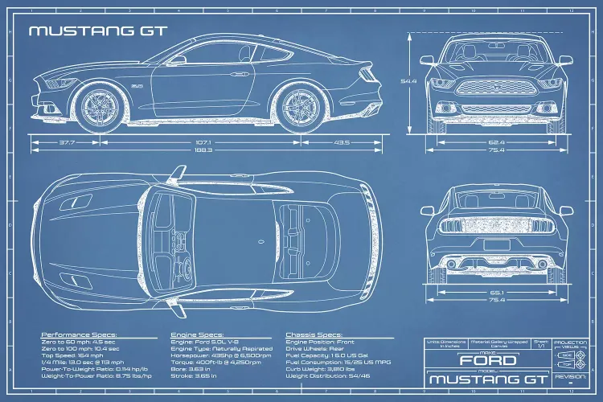

Source 1: Mustang GT blueprint: <https://www.icanvas.com/canvas-print/mustang-gt-2015-2017-blueprint-abp44#1PC6-40x26>

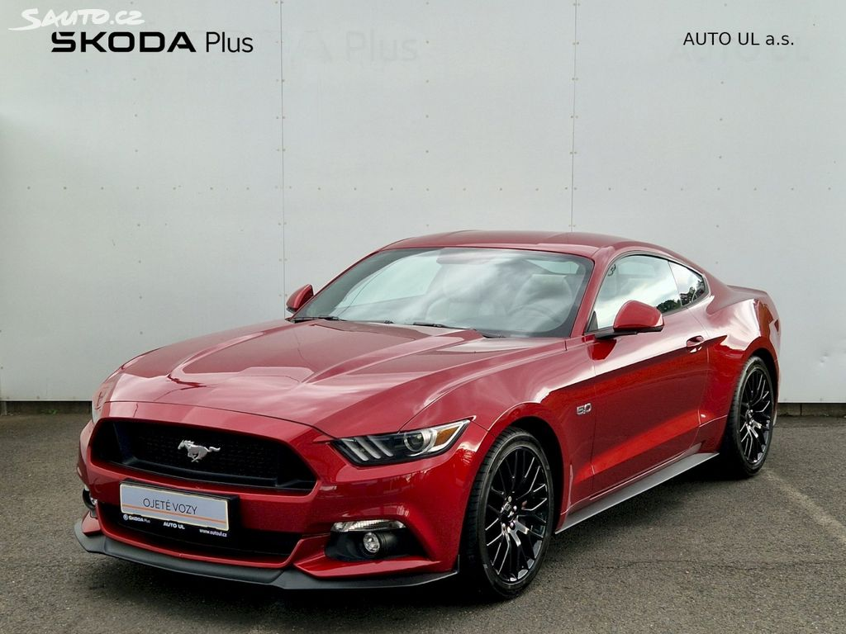

Source 2: Ford Mustang Fastback <https://www.sauto.cz/osobni/detail/ford/mustang/197783197>

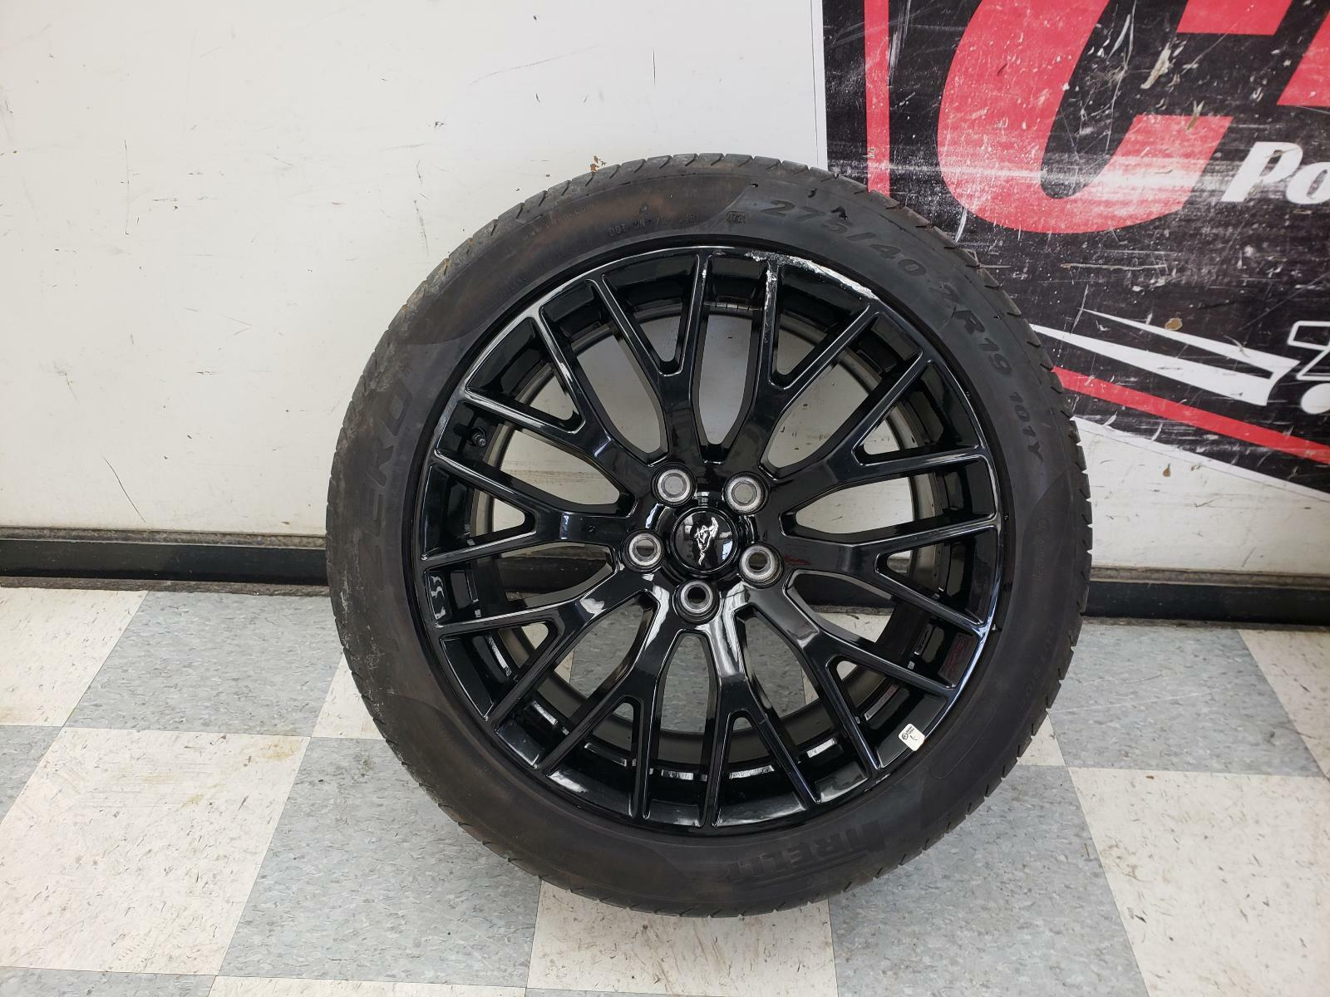

Source 3: Mustang tire <https://www.ebay.com/itm/313891558045>

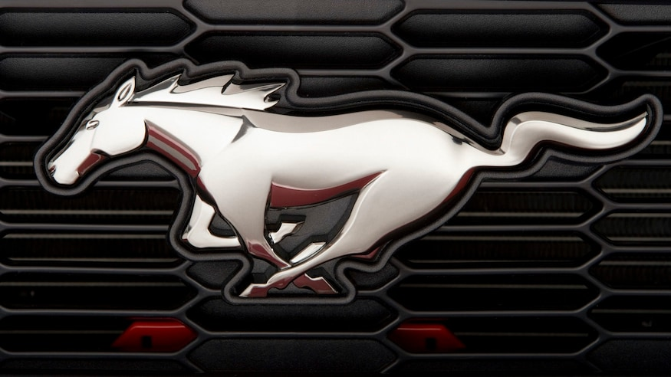

Source 4: Mustang logo <https://www.motortrend.com/features/ford-mustang-logo-badge-history/>

## 3D modeling

### Task:

* Create a 3D model of a car according to your reference materials (10 points).
* Use modifiers to create the 3D model (e.g., mirror, subdivision surfaces) (2 points)
* The body and chassis of the car will be represented by one 3D object. There will be only one geometry of the wheel, that all the wheels will share. (2 points)
* The 3D object representing the body and chassis of the car will be the parent of the 3D objects representing the wheels. (1 point)

### 3D modeling process

*3D modeling tool: Blender 3.4.1*

*Used modifiers: Mirror, Subdivision Surface, Solidify, Array*

*Used tools: Knife, Extrude, Loop Cut, Insert Faces*

*Time: 32.0 hours (2 hours on scrapped 1st try, rest on the model in this paper)*

### Part I: Setting up the scene.

Before starting the modeling, I needed to create a basic shape. Out of experience, I didn’t try to model each side separately, which leads to problems in merging the sides. Instead, I tried a different approach. First, I imported background images using *“Add->Image->Background”*. Afterward, I added a plane, into which I inscribed the shape of the car from the top using a “*Knife tool*”.

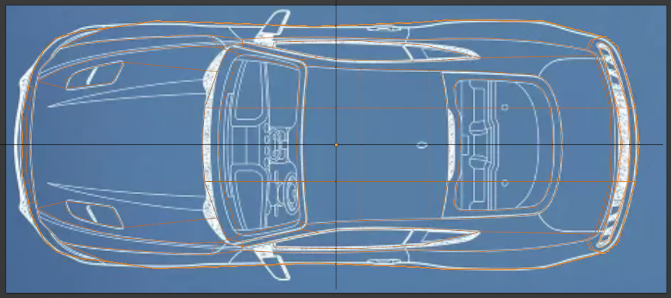

Figure 1: Car projected onto a plane.

When I created the plane with the projected top of the car, I looked from different angles to determine the correct height for each point.

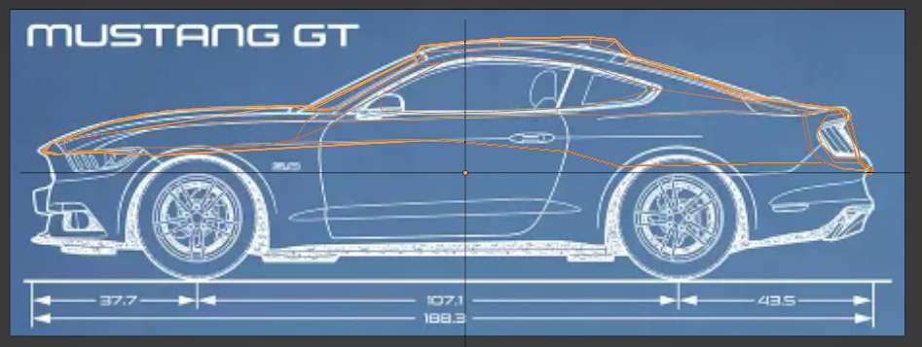

Figure 2.1: Projected top of the car with correct heights

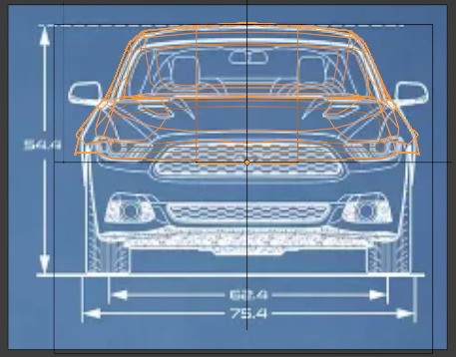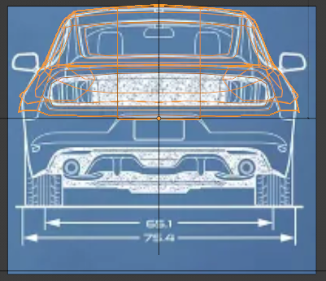

Figure 3.2: Projected top of the car with correct heights

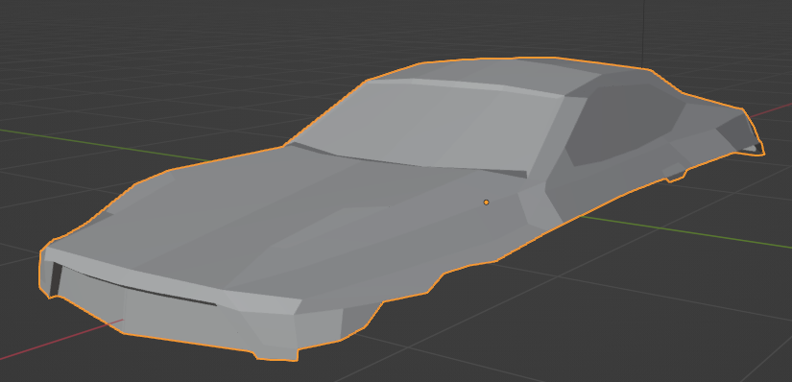

Figure 2.3: Project the top of the car as an object

When I determined the correct heights, I extruded the sides of the car down the way. From there I added more detail to the front and the back of the car.

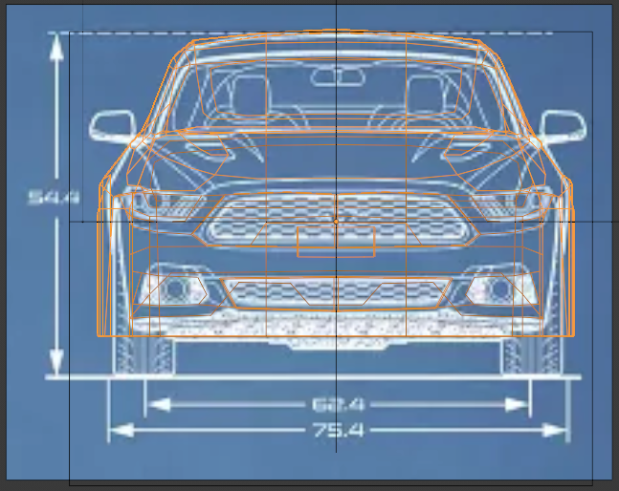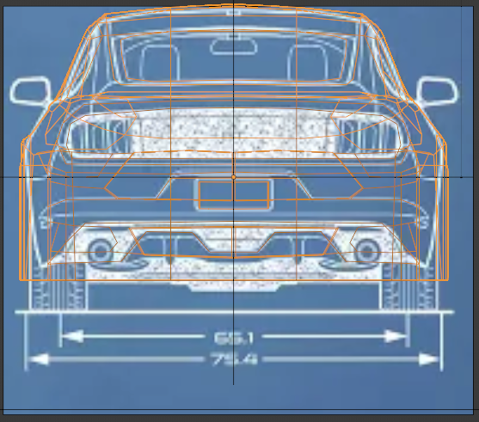

Figure 3: Extended front and back of the car

Now that the car is mostly done, I am adding detail to the side of the car as well as fixing any mistakes created from discontinuity between reference images as well and adding a chassis to enclose the model. Finally, we make holes in tires by extruding the created planes inside.

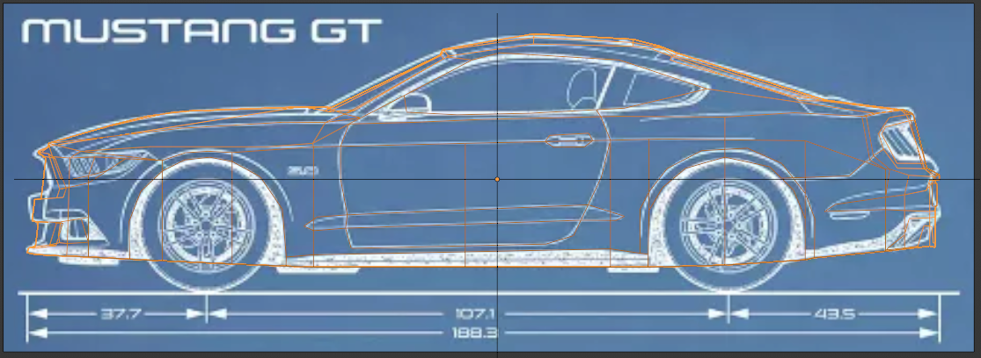

Figure 4: Detail on the side of the car

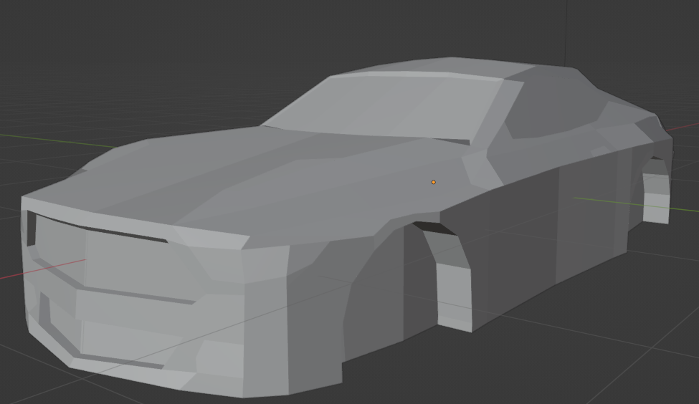

Figure 5: Car Model

### Part II Modelling.

Now that I have a basic shape of the car, I tried cleaning the topology a little, since by cutting the plane, I created many polygons with multiple vertices, that are not ideal for modeling. I mostly replaced these polygons with cuts going through the whole car using “Loop Cut” and “Knife tool”, creating triangles and quads. Then by using the reference images, I transformed the model to look more like the Ford Mustang.

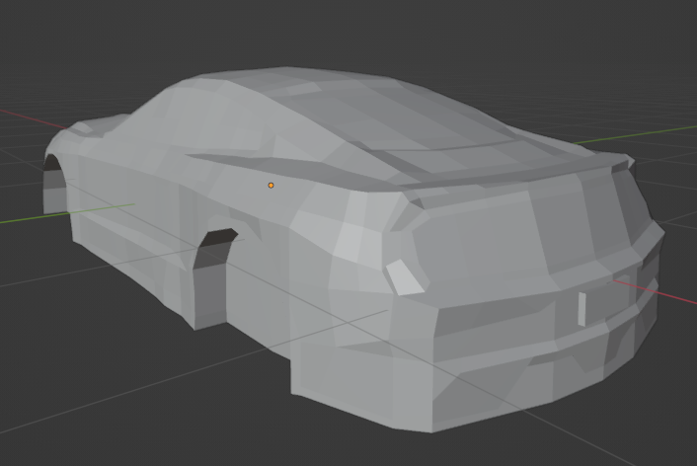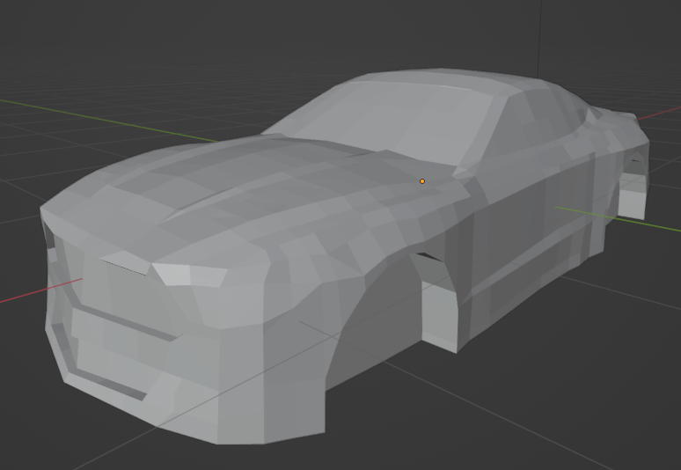

Figure 6: Car with more detail

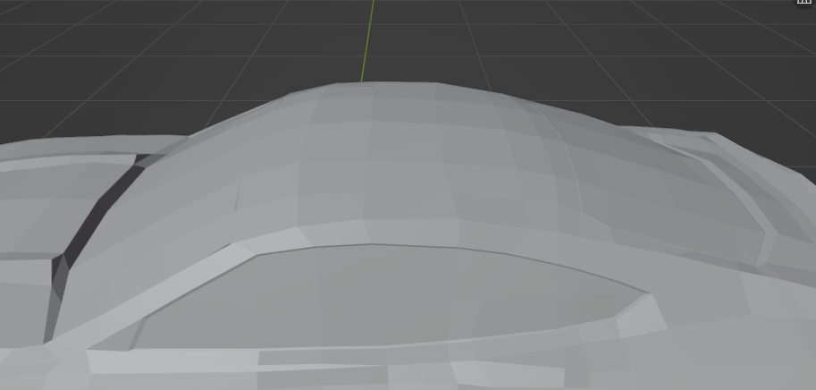

Figure 7: Details on windows

### Part III: Subdivision Surface.

When the car had the general shape, I started creating details. But instead of subdividing the geometry, I added detail using the “Subdivision Surface” modifier with smooth shading, which made the car smooth, but there were multiple problems with that. I needed to keep many edges sharp, so while having this setting on, I added “Crease” to some specific edges.

I continued working on the car with these modifiers while adding even more details along the way. I started working on the front of the car. There I noticed that there are some differences between the images and the blueprint of the car in front. For that reason, I continued with the blueprint version and found some other image references for these specific parts.

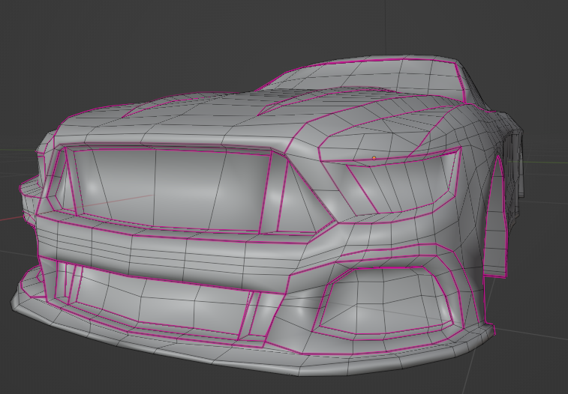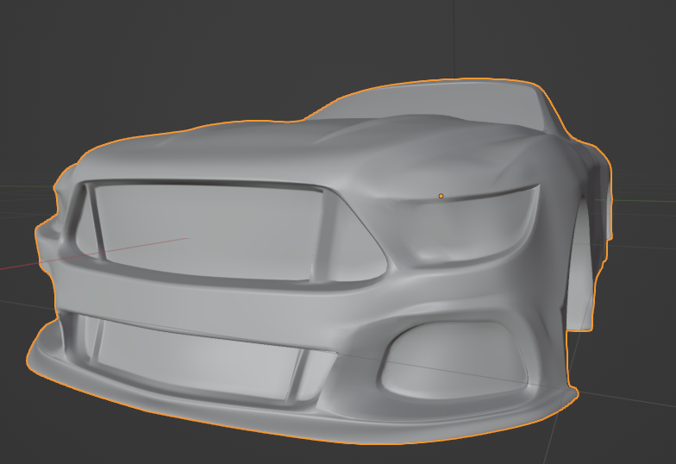

Figure 8: Subdivision of front of the car

Next, I needed to add a honeycomb pattern on the grille. I started by creating a single part of the pattern, that I could repeat using an array modifier. Then I used the “Shrinkwrap” modifier to fit it on the grille, which I cloned beforehand.

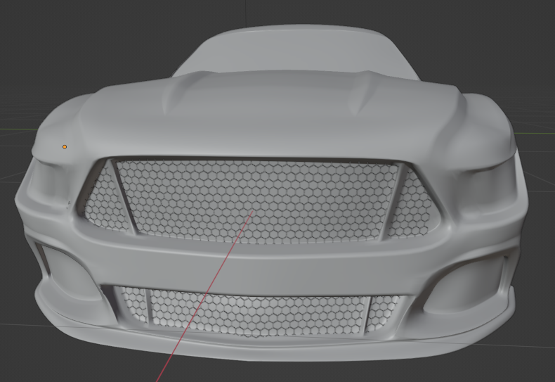

Figure 9: Car Grille

Afterward, I continued adding details about the car. This means the side of the car, the windows, and the back of the car.

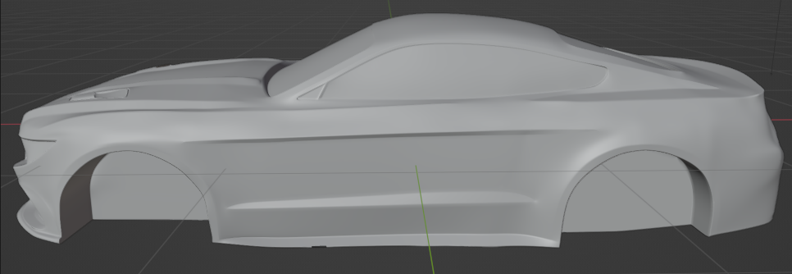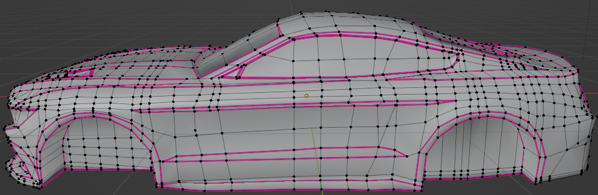

*Figure 10: Detailed side of the car*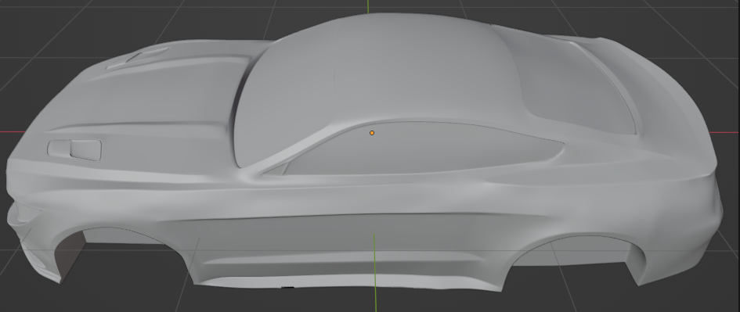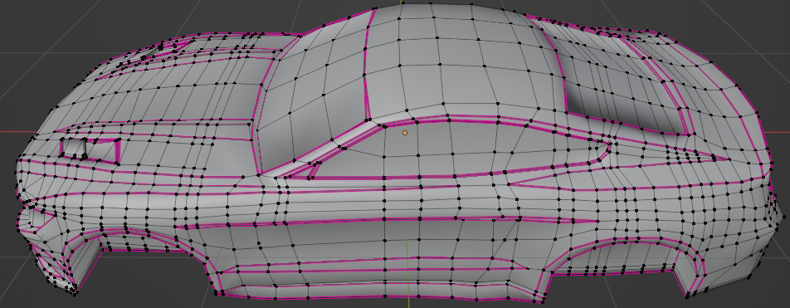

Figure 11: Detailed top of the car

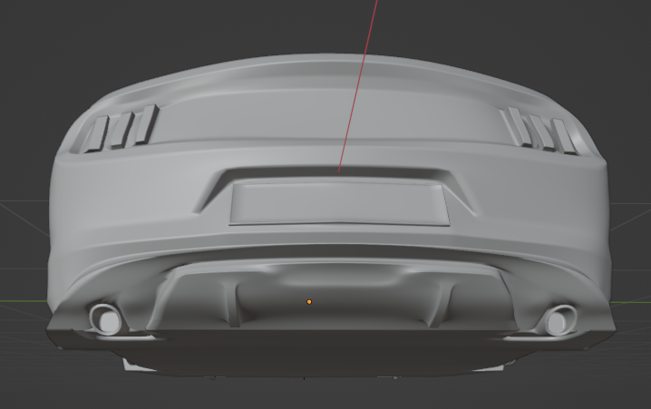

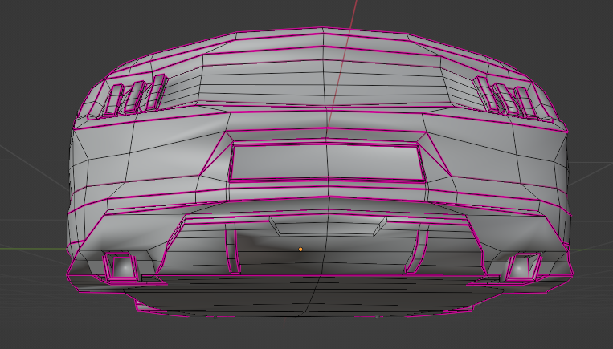

Figure 12 Back of the car

With this, the car was nearly completed. The only things left were details and wheels.

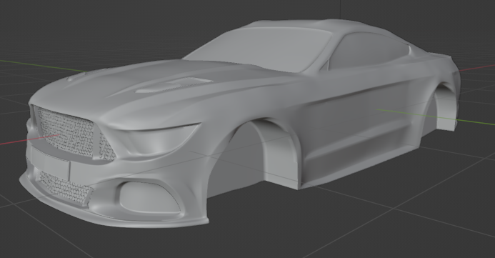

Figure 13 Completed main part of the car.

### Part IV: Wheel

After I was satisfied with the details, for the time being, I switched my focus to creating wheels. The wheel can be divided into 10 identical segments. In the beginning, I created a segment of the wheel. As every segment is also symmetrical, I split it in half and added a mirror modifier to make my work easier. Then to create the wheels, I used the “Array” modifier on part of a circle, which I set to have the Object offset to an empty object, which I created beforehand. After setting the array modifiers to have 10 copies (as well as turning on merge to create one object) and rotating the empty object by 36 degrees on the z-axis, the array modifier created a full circle, which will represent the wheel.

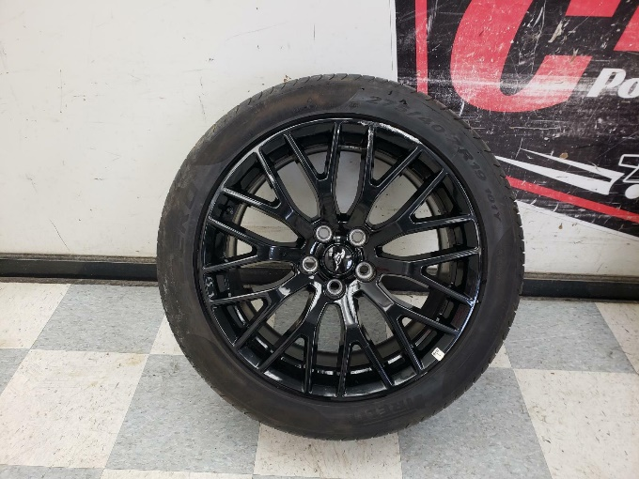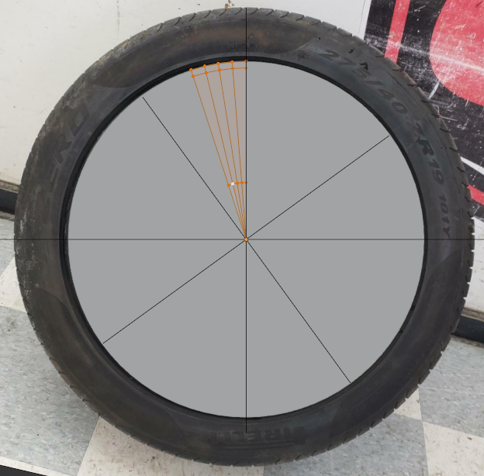

Figure 14: Wheel reference and object

Now I could focus only on one segment while letting the modifier create the whole wheel. Then after some cutting and modelling, we create a replica of the wheel.

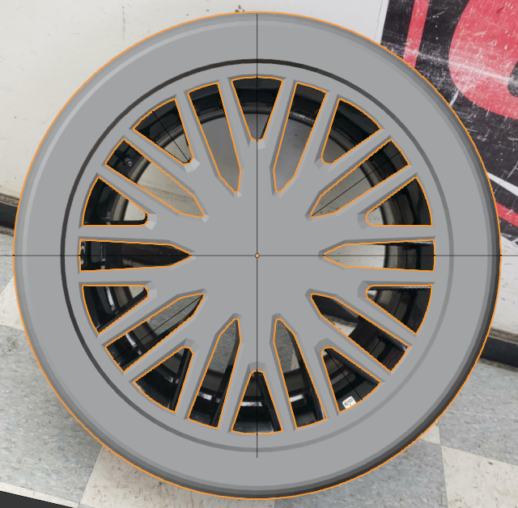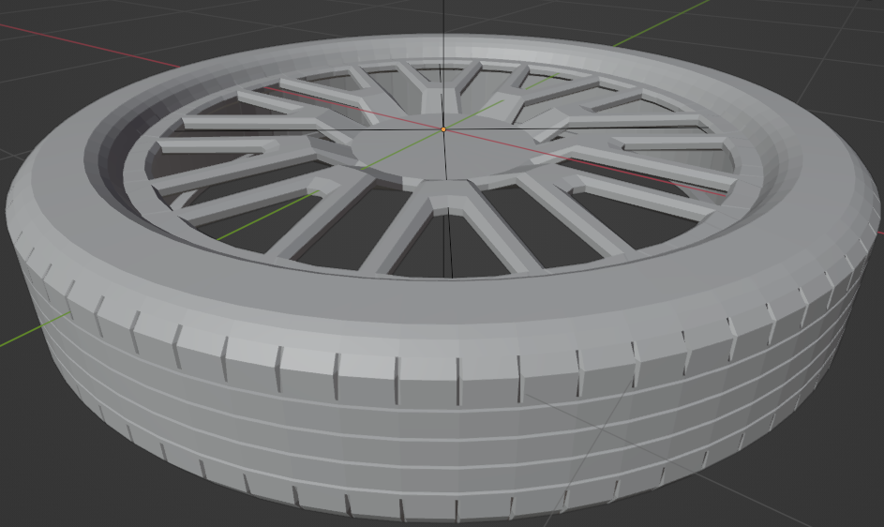

Figure 15: Wheel Creation

After the symmetrical part of the wheel was created, I cleaned the model for the subdivision surface modifier by adding crease to selected edges, just as before. Then, I applied all the modifiers so I could focus on the break cylinders behind the wheel.

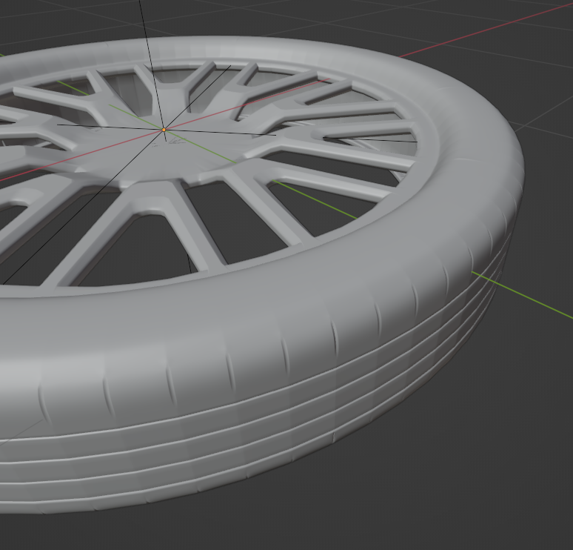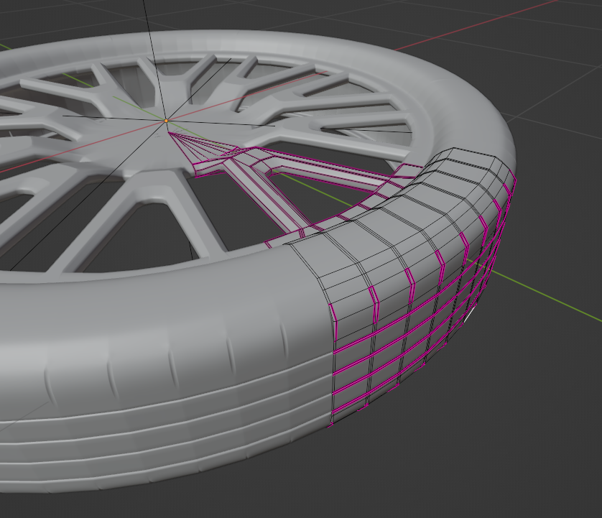

Figure 16: Subdivision Surface

Next, we continue with the brake cylinder, which we create simply from the circle. To make it easily into a 3D object, we use the “Solidify” modifier.

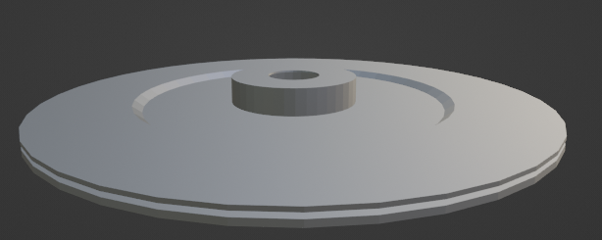

Figure 17: Brake cylinder

The last thing I added were brake pads and a brake cover.

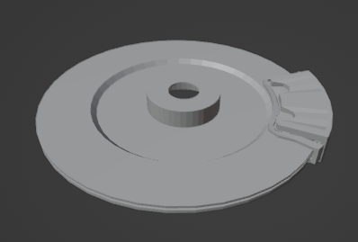

Figure 18: Brake pads and cover

Then finishing touches by adding bolts to the wheel and it is done.

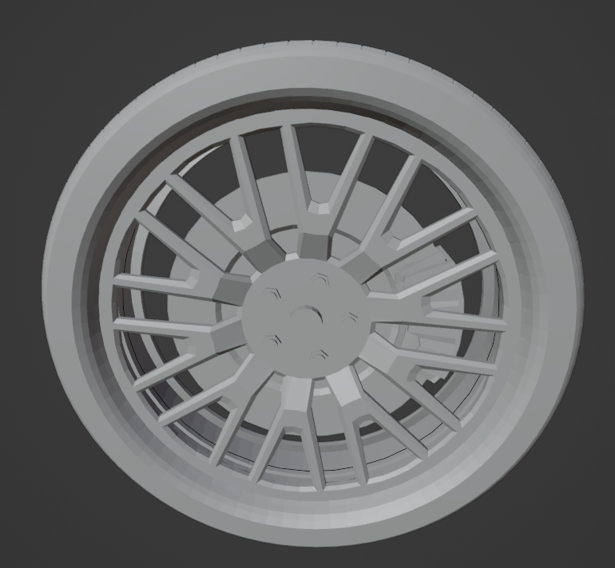

Figure 19: Finished wheel

Then using two *“array”* modifiers I added them to the car.

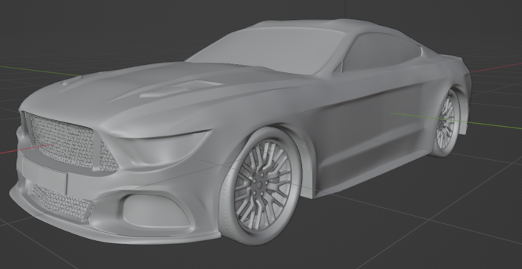

Figure 20: Car with wheels.

### Part V: Details

The first of the details was the Mustang logo. I started by cutting out the general shape of the plane using the “*Knife*” tool. Next, I extruded the cut horse to create a 3d object, which I started shaping using a “subdivision surface” to the expected shape. Lastly, I created the layers on the logo by extruding the specific parts. To finish I moved some parts up again to add depth to the model as well as create eye and ear holes of the horse.

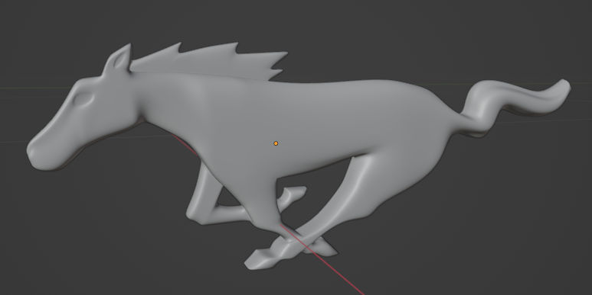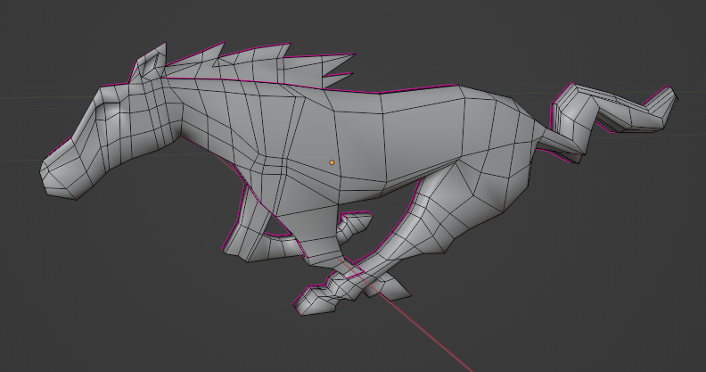

Figure 21: Mustang logo

Another detailed logo was the car type “5.0” on the side and “GT” at the back. Same as the Mustang logo I first cut the shape out of the plane and using extrude I shaped it into the current font.

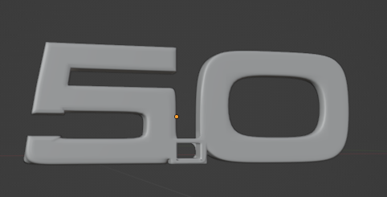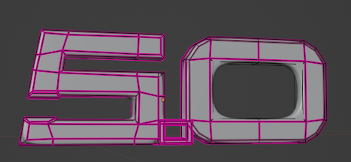

Figure 22: Car type 5.0

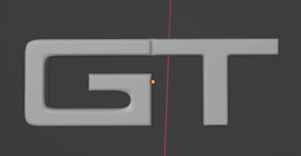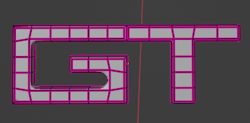

Figure 23: Car type GT

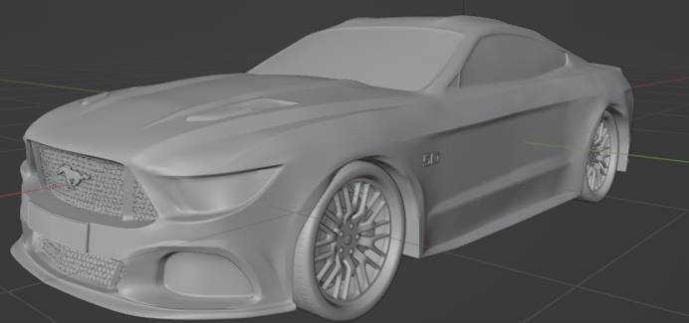

Figure 24: Car with more details

Now we continue with additional details. The first thing (I have been ignoring until now) is modeling the front lights, rear mirrors, car door handles as well as cuts to the body, where the separate parts are connected (such as the hood of the car).

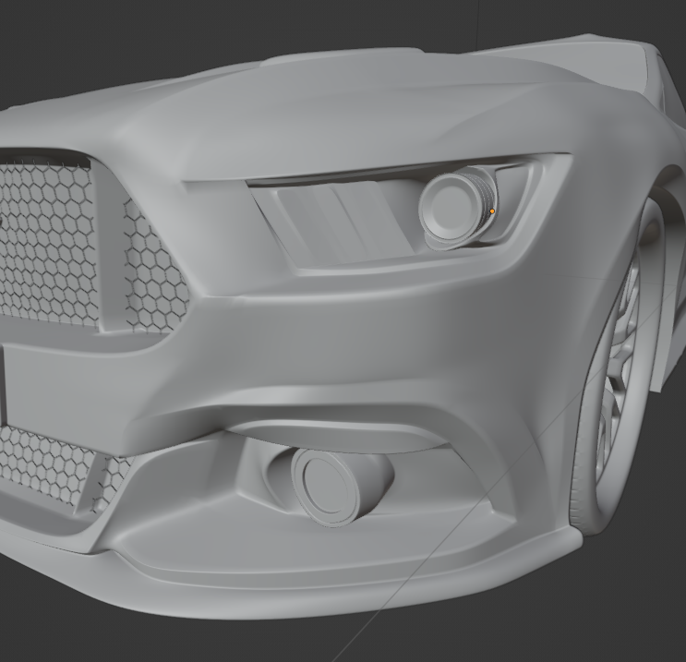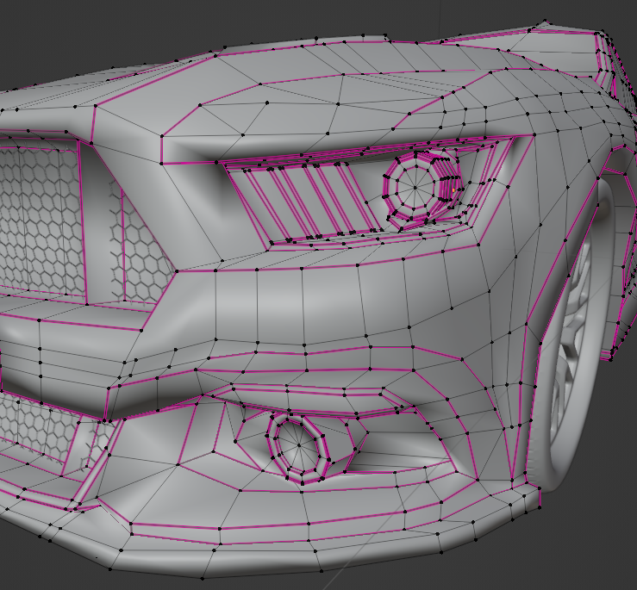

Figure 25: Front lights

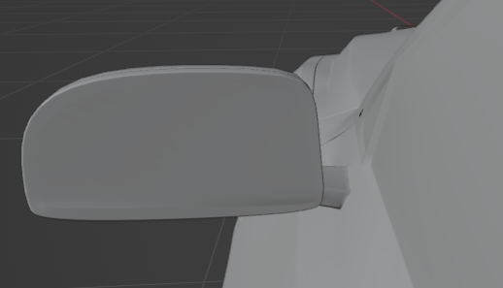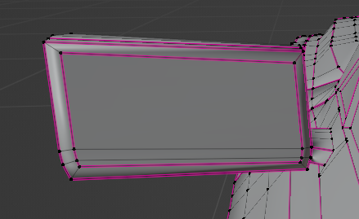

Figure 26: Rear mirrors

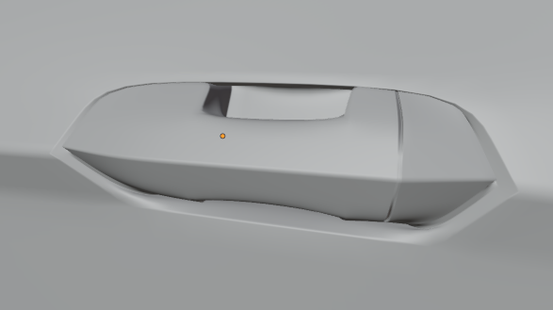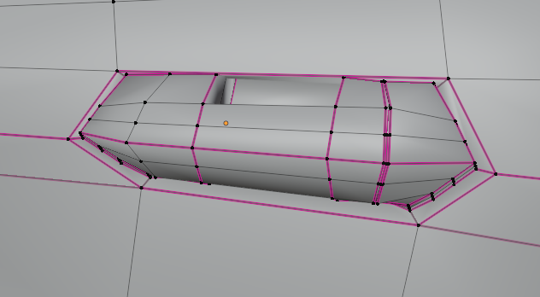

Figure 27: Door handle

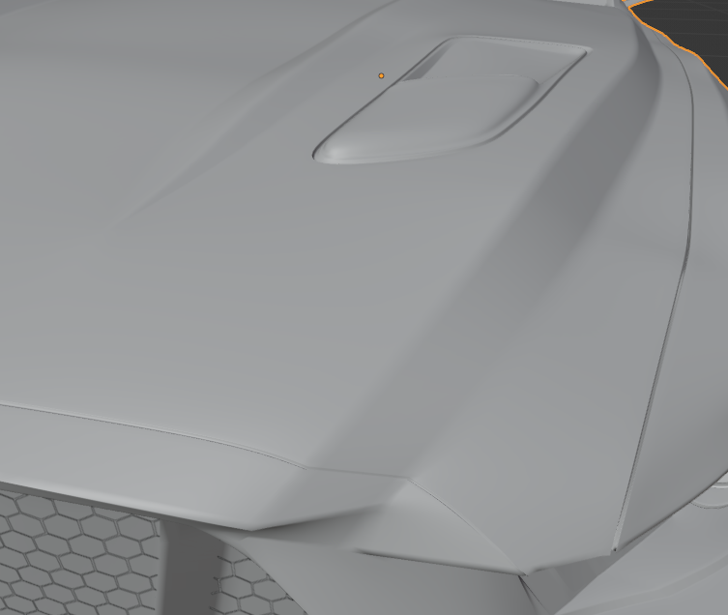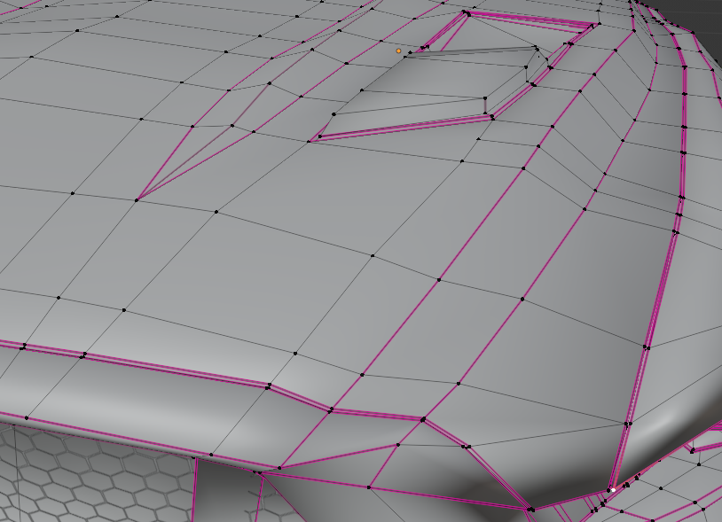

Figure 28: Front body cuts

## Result

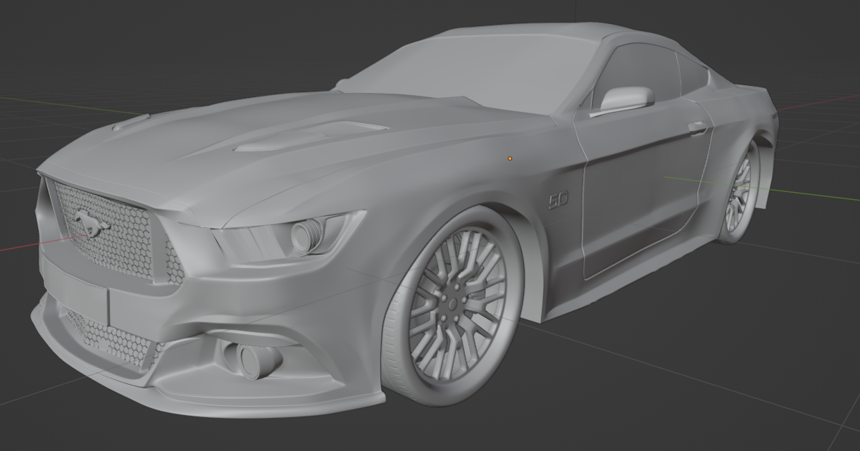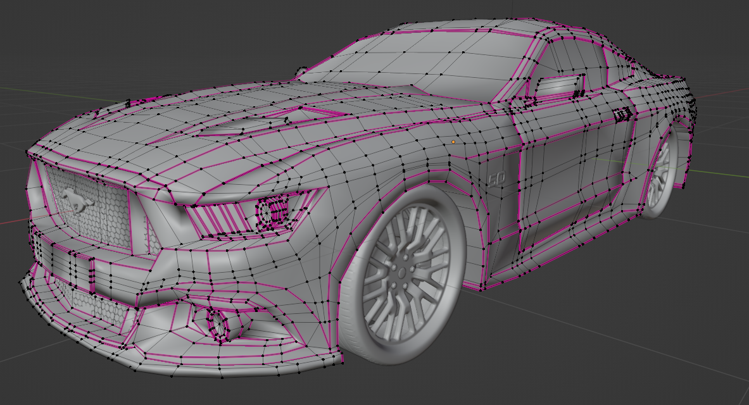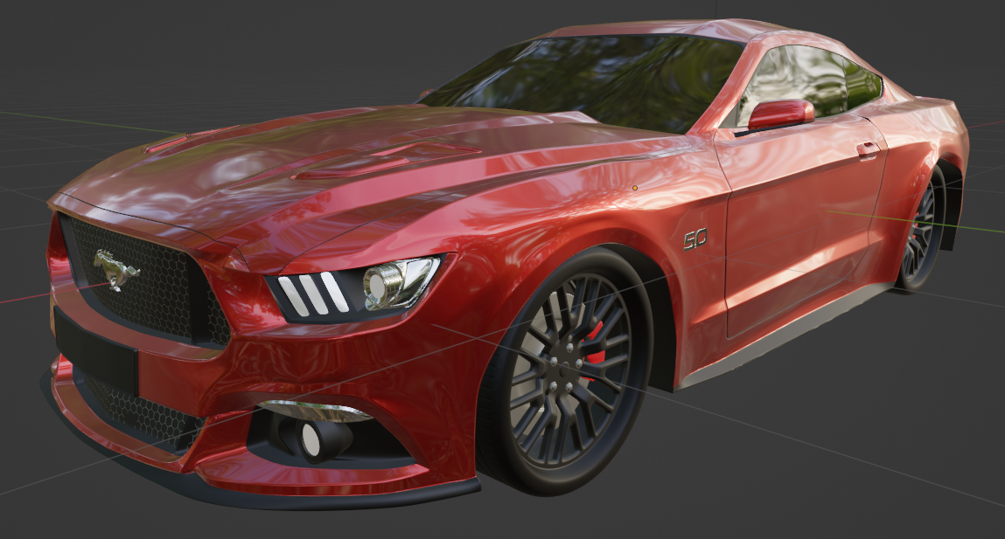

Figure 29: Result set 1

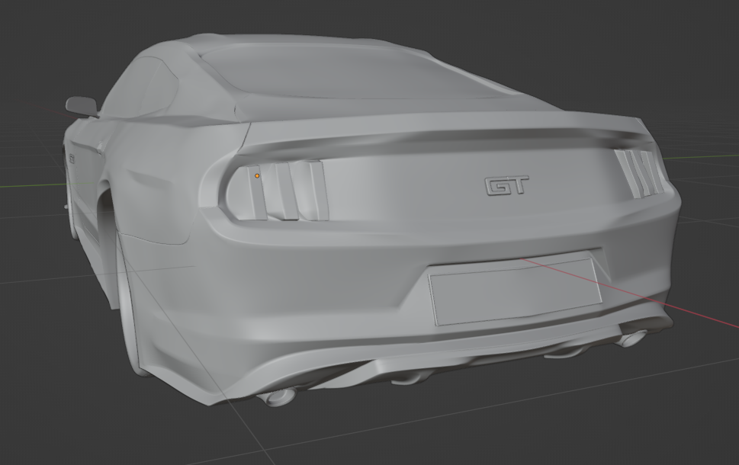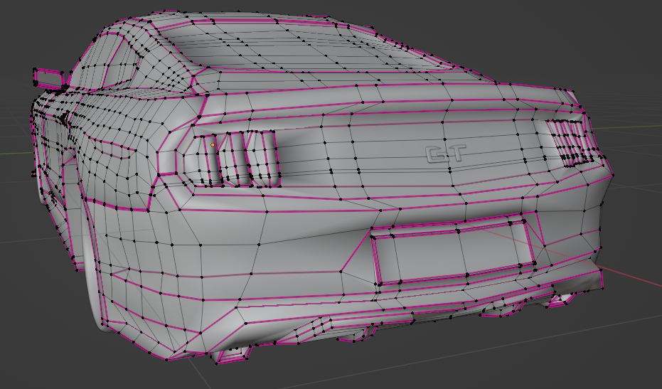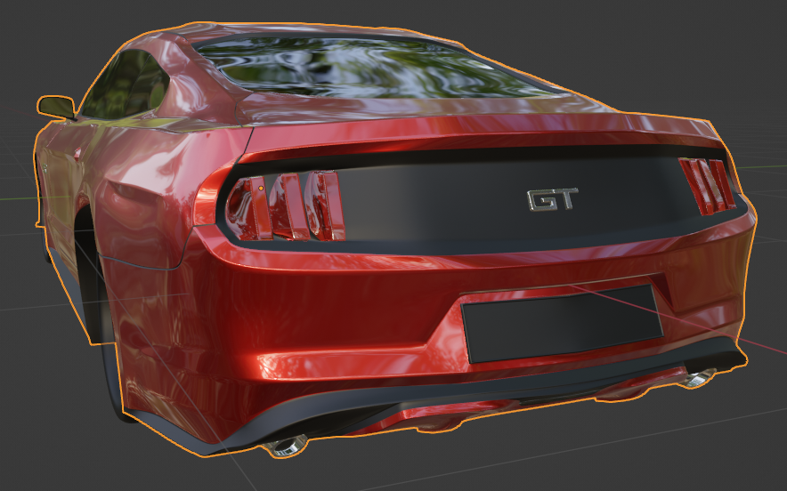

Figure 30: result set 2

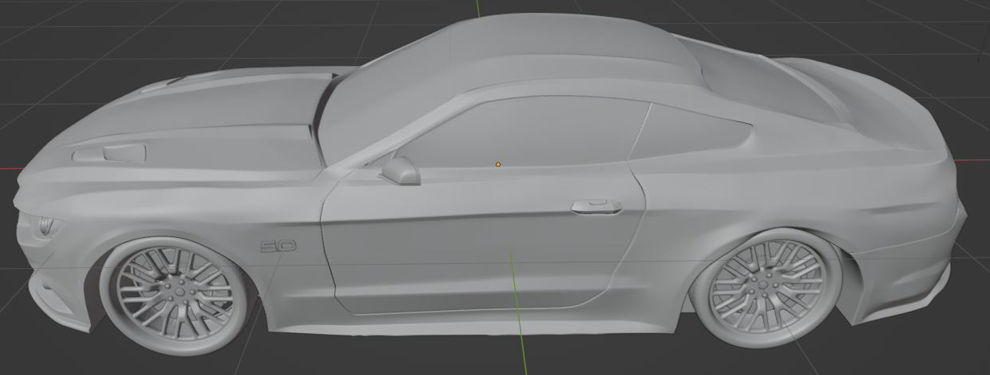

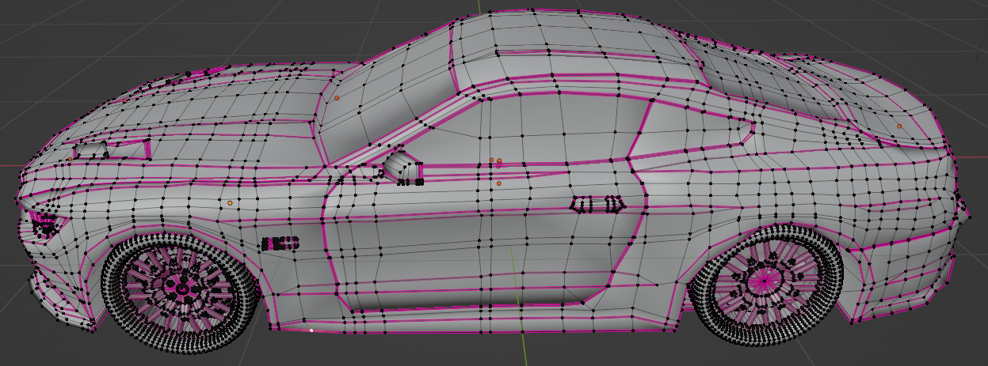

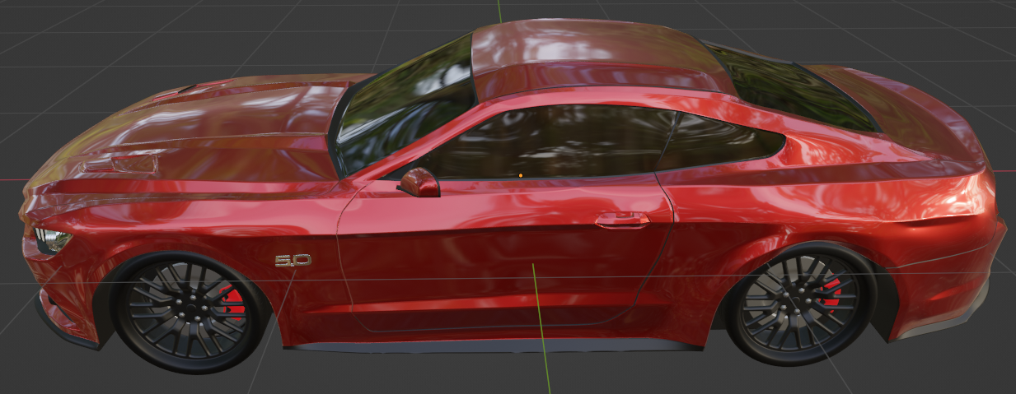

Figure 31: Result set 3